ASSIGNMENT 11

Name : Akanksha Joshi

Roll No : B038

Batch : 3

Div : BTech CS B

--------------------------------------------------------------------------------------------------------------------------

Q1.Consider two variables 'a' and 'b' in Python such that a = 4 and b = 5. Swap the values of 'a' and 'b' without using a temporary variable. Print the values of 'a' and 'b' before and after swapping.

Source Code

a = int(input("Enter number 1: "))

b = int(input("Enter number 2: "))

b = a+b

a = b-a

b = b-a

print("Value of number 1: " + str(a))

print("Value of number 2: " + str(b))

Output

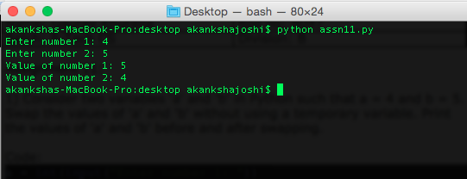

Q2.Consider the scenario of processing marks of a student in ABC Training Institute. John, the student of ﬁfth grade takes exams in three diﬀerent subjects. Create three variables to store the marks obtained by John in three subjects. Find and display the average marks scored by John.

Now change the marks in one of the subjects and observe the output. Did the value of average change?

Source Code

a = int(input("Enter marks 1: "))

b = int(input("Enter marks 2: "))

c = int(input("Enter marks 3: "))

avg = (a+b+c)/3

print("Average marks: " + str(avg))

c = int(input("Enter new marks 3: "))

new_avg = (a+b+c)/3

print("New average marks: " + str(new_avg))

Output

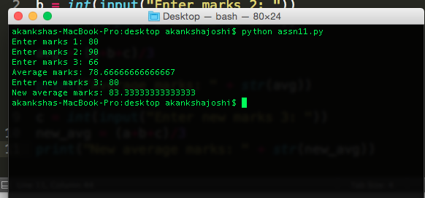

Q3.Given the value of radius of a circle, write a Python program to calculate the area and perimeter of the circle. Display both the values.

Source Code

r = int(input("Enter radius : "))

area = 3.14*r*r

perimeter = 2*3.14*r

print("Area of circle is : " + str(area))

print("Perimeter of circle is : " + str(perimeter))

Output

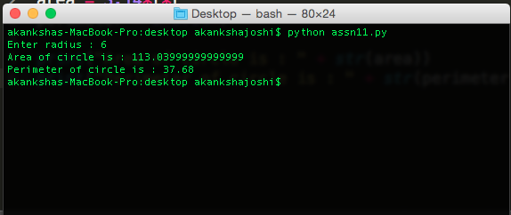

Q4.The ﬁnance department of a company wants to compute the monthly pay of its employees. Monthly pay should be calculated as mentioned in the formula below. Display all the employee details.

* Monthly Pay = Number of hours worked in a week * Pay rate per hour * No. of weeks in a month
* The number of hours worked by the employee in a week should be considered as 40
* Pay rate per hour should be considered as Rs.400
* Number of weeks in a month should be considered as 4

Source Code

name = input("Enter employee name: ")

id = input("Enter employee id: ")

no_hours = int(input("Enter number of hours worked: "))

pay_rate = int(input("Enter the rate of pay: "))

no_weeks = int(input("Enter number of weeks: "))

monthly_pay = no_hours*pay_rate*no_weeks

print("Monthly pay of employee is : " + str(monthly_pay))

Output

